**Cubic Rig Reconfiguration**

## Link Scripts

As usual; LinkSSOFTPScript.ps1

~\LinkSSOFTPRigs.cubic.ps1 -SSORig "CubicACC_FTP_Rig_Name"

-FTPRig " CubicACC_FTP_Rig_Name"

-FTPWebAlias 'cer-cas.prestige.test' -SSOWebAlias 'cer-sso.prestige.test'

-FTPPassword "FTPacc535#" -SSOPassword "LMTF`$Bu1ld"

~\LinkSSOFTPRigs.cubic.ps1 -SSORig "CubicInt_FTP_Rig_Name"

-FTPRig "CubicInt_FTP_Rig_Name"

-FTPWebAlias "int-cas.prestige.test" -SSOWebAlias "int-sso.prestige.test"

-FTPPassword "FTPacc535#" -SSOPassword "LMTF`$Bu1ld"

## Load Balancer Reconfig

F5 UI: https://10.107.203.15/tmui/login.jsp

u=xRichardLocke; p=RichardLocke

->Local Traffic (right hand menu)

Virtual Servers; Pools; Pool List - Search by "Cubic" (case sensitive)

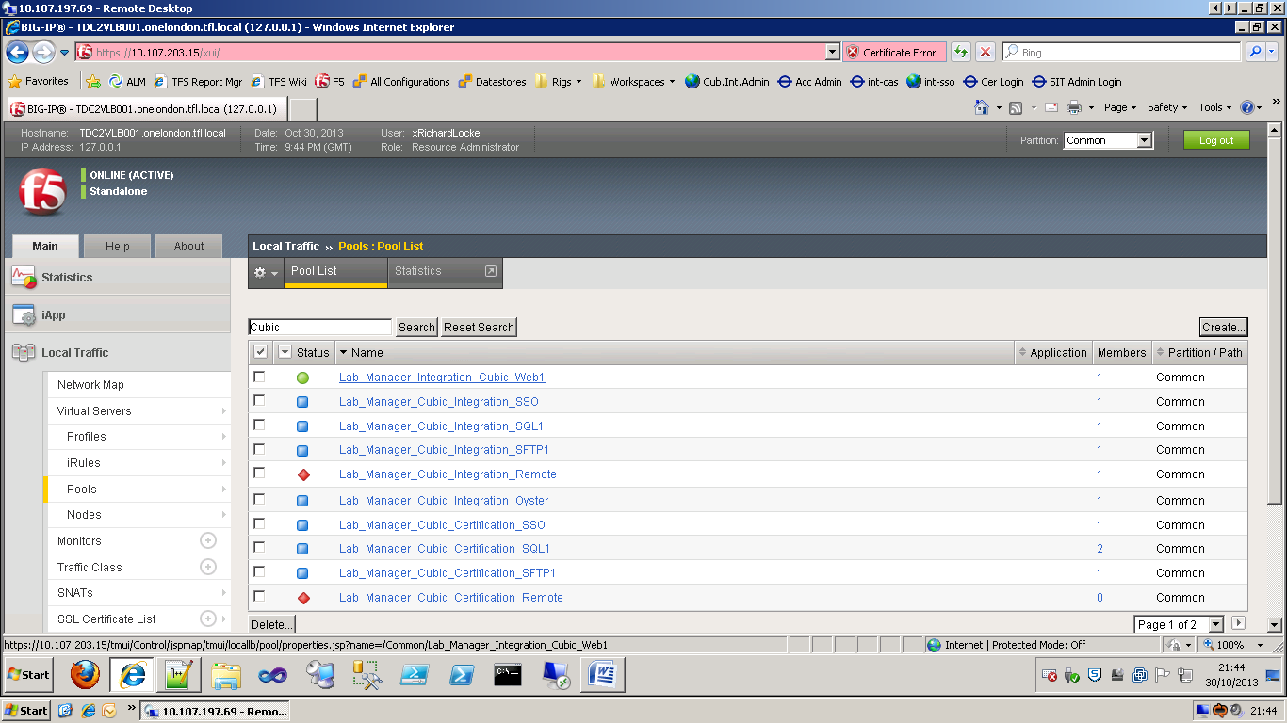

Edit: Lab_Manager_Integration_Cubic_Web1 (click the name)

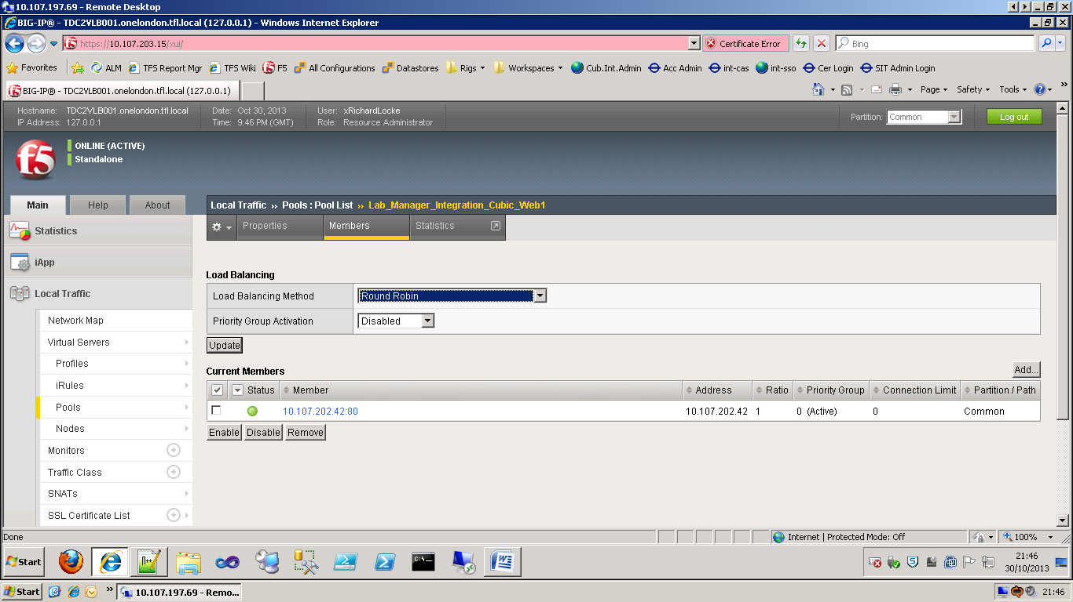

You can't edit existing members IP addresses so you have to add a new one and remove the old one.

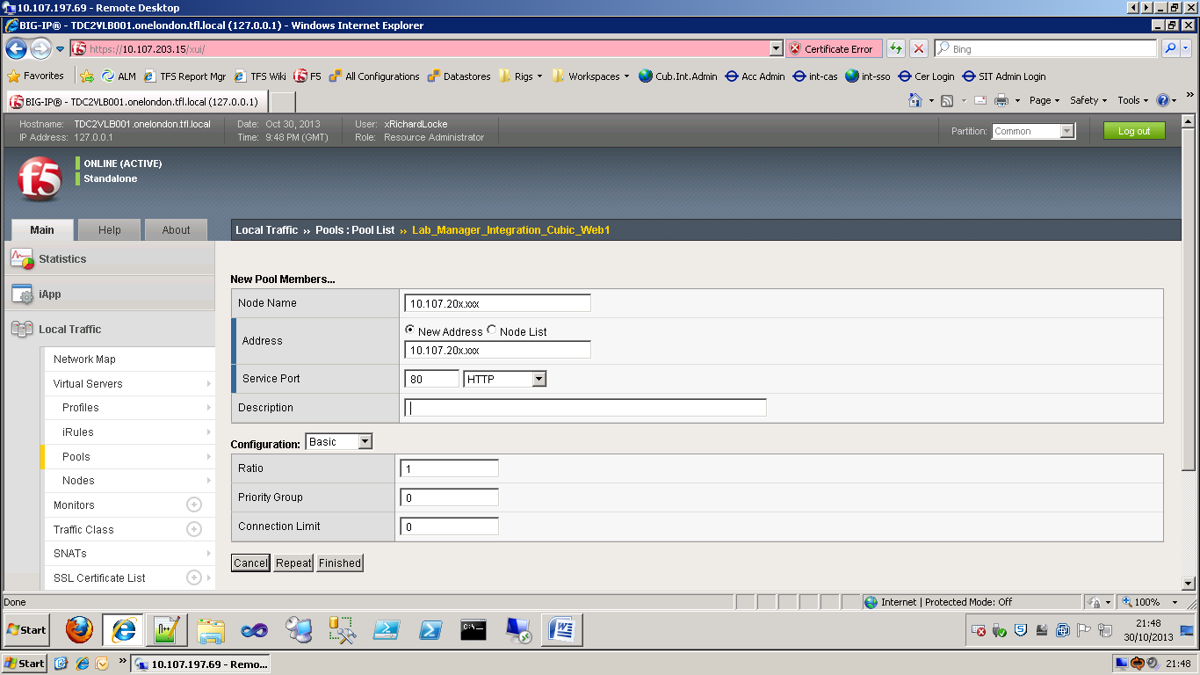

Enter the new IP address for the Node Name and Address.

Enter the port

'Finished'

Entries requiring changing:

|  |  |  |  |
| --- | --- | --- | --- |
| Lab_Manager_Integration_Cubic_Web1 | CubicInt.FTP | TS-CAS1 | 80 |
| Lab_Manager_Certification_Cubic_Web1 | CubicAcc.FTP | TS-CAS1 | 80 |
| Lab_Manager_Cubic_Integration_SSO | CubicInt.SSO | TS-CAS1 | 0 |
| Lab_Manager_Cubic_Certification_SSO | CubicAcc.SSO | TS-CAS1 | 0 |
| Lab_Manager_Cubic_Integration_SFTP1 | CubicInt.FTP | TS-FTM1 | 22 |
| Lab_Manager_Cubic_Certification_SFTP1 | CubicAcc.FTP | TS-FTM1 | 22 |
| *\* Lab_Manager_Cubic_Integration_Oyster* | *IPP.UAT.FTP.Brixton* | *TS-CAS1* | *0* |
| *Lab_Manager_Cubic_Certification_Oyster* | *Not yet created* |  |  |

* Oyster's a funny one; think this was created as a place holder.

The ... SQL1 entries are redundant; they don't connect to sql via the load balancer (this isn't related to Service Broker, that doesn't work at all through load balancers).

The ... Remote entries are redundant; they don't connect to the rigs via RDC via the VIPs.

|  |  |  |  |
| --- | --- | --- | --- |
| Eckoh_CSCTokenStatusService_iApp_pool | CubicInt.FTP | TS-CAS1 | 8716 |
| Eckoh_CustomerService_iApp_pool | CubicInt.FTP | TS-CAS1 | 8720 |
| Eckoh_SCSAuthorisationService_iApp_pool | CubicInt.FTP | TS-CAS1 | 8718 |
| Oyster_Sandpit1_CustomerPortal | SIT.FTP(most recent successful IPP rig) | TS-CAS1 | 80 |
| Oyster_Sandpit1_SSOWeb | SIT.SSO | TS-CAS1 | 0 |
| Oyster_Sandpit2_CustomerPortal | SIT.FTP | TS-CAS1 | 80 |
| Oyster_Sandpit2_SSOWeb | SIT.SSO | TS-CAS1 | 0 |